HTML Block & Inline

**Table of content**

* What is block element in HTML?
* How to create a block in HTML?
* What is Inline element in HTML?
* Explain div element in HTML.
* Explain Span element in HTML.

**What is block element in HTML?**

HTML language allows the user to create the block like structure which can be considered as a table like structure in the document but for creating the block element table tag not required. Black element in HTML is use for creating block like structure with the help of <div tag>. Adding div tag in the document is a concept which follows some sort of standard rule like it will occupy full with by default and always start with new line in the document.

**Example-**

<!DOCTYPE html>

<html lang="en">

<head>

    <meta charset="UTF-8">

    <meta name="viewport" content="width=device-width, initial-scale=1.0">

    <title>block element</title>

</head>

<body>

    <div style= "background-color: cyan; font-size: xx-large; text-align: center; width: 500px; height:500px ;" ></div>

</body>

</html>

**Output-**

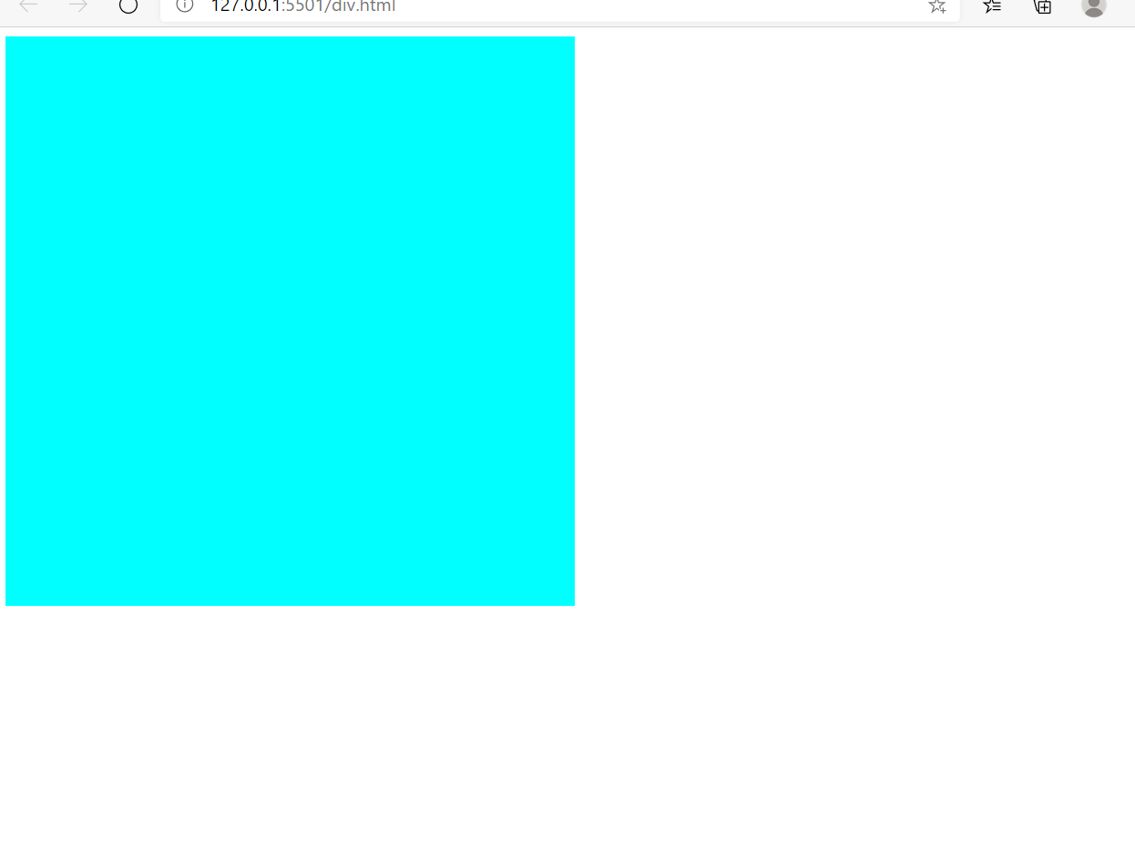

**How to create a block in HTML?**

Block means creating a structure which always occupy a space from new line and having full width in it. Creating a block means a concept of creating table like structure without using table tag. Block element can be represented by <div> tag in HTML.

**Example-**

<!DOCTYPE html>

<html lang="en">

<head>

    <meta charset="UTF-8">

    <meta name="viewport" content="width=device-width, initial-scale=1.0">

    <title>block element</title>

</head>

<body>

    <div style= "background-color: cyan; font-size: xx-large; text-align: center; width: 500px;" >Example of block element</div>

</body>

</html>

**Output-**

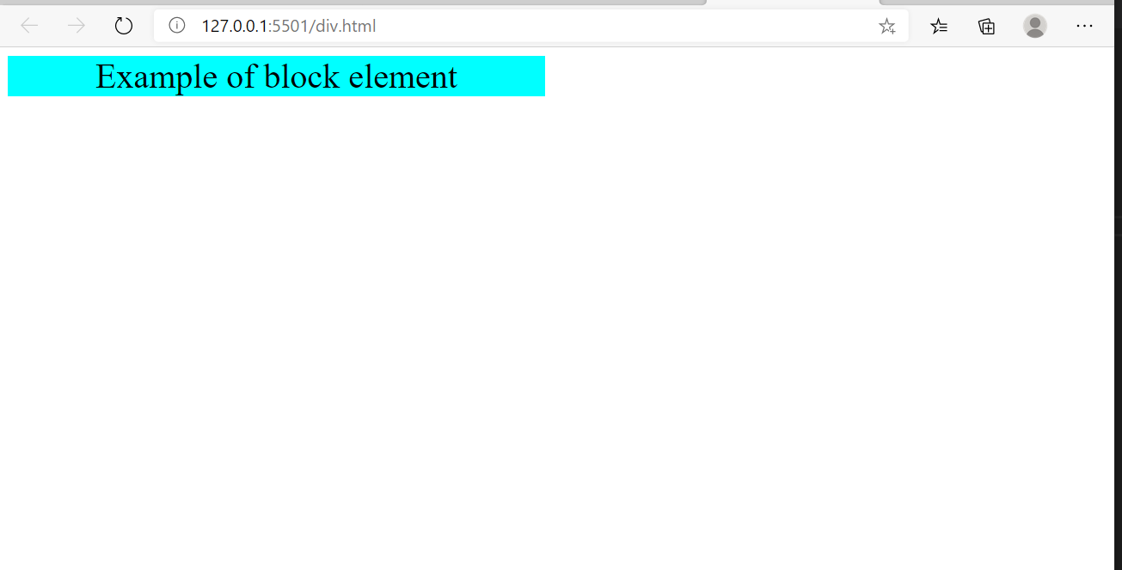

**What is Inline element in HTML?**

Inline Element is nothing but the concept of defining the formatting properties or attribute within the main element. By default every element within the HTML tag is considered as a Inline element in the document. There are many more HTML attributes can be defined under the inline element for formatting. The attributes use in the inline element is <a>, <span>, <cite>, <img> and many more.

**Example-**

<!DOCTYPE html>

<html lang="en">

<head>

    <meta charset="UTF-8">

    <meta name="viewport" content="width=device-width, initial-scale=1.0">

    <title>Document</title>

</head>

<body>

    <style>

        body {

            background-color: rgb(231, 248, 204);

        }

    </style>

    <h2>This is an example of inline element where i have only add background color and font size.</h2>

    <div style="font-size: xx-large; background-color: rgb(233, 112, 112);" text-align="center"> Geeky4u.com</div>

</body>

</html>

**Output-**

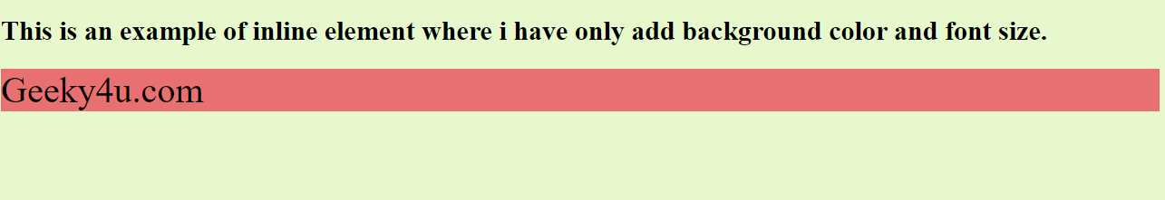

**Explain div element in HTML.**

**In HTML div element is act like an attribute which is generally apply on the HTML element. This element works like a block of code in which all the attribute has define. In HTML div attribute is use as inline element so that it does not required any external attribute like id, class or style to call the block of code.**

**Syntax-** <div> text </div>

**Example-**

<!DOCTYPE html>

<html lang="en">

<head>

    <meta charset="UTF-8">

    <meta name="viewport" content="width=device-width, initial-scale=1.0">

    <title>Document</title>

</head>

<body>

    <style>

        h1 {

            background-color: rgb(127, 203, 238);

            text-decoration-color: rgb(138, 108, 108);

        }

        body {

            text-align: center;

            background-color: rgb(195, 243, 252);

        }

    </style>

    <div style="background-color: rgb(23, 228, 228);">

        <h1>Geeky4u.com(Learn with passion)</h1>

        <p>This is a best learning platform with best of all.<br> you can explore yourself and rate yourself <br>where

            exactly you are in the technical skills</p>

        <h3>Thanks</h3>

    </div>

</body>

</html>

**Output-**

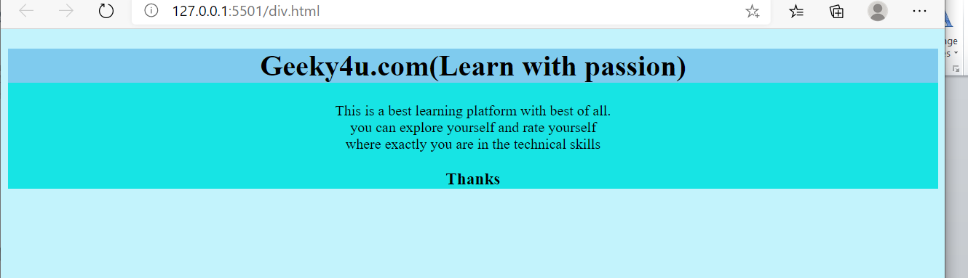

**Explain Span element in HTML.**

Span tag is a concept of providing a formatting attribute only on the limited or selected text. While writing text if user wish to highlight some part of the text then span tag is use.

<span> tag need to use before and after the code where you wish to apply the formatting in the text.

**Example-**

<!DOCTYPE html>

<html lang="en">

<head>

    <meta charset="UTF-8">

    <meta name="viewport" content="width=device-width, initial-scale=1.0">

    <title>Document</title>

</head>

<body>

    <style>

        h1 {

            background-color: rgb(127, 203, 238);

            text-decoration-color: rgb(138, 108, 108);

        }

        body {

            text-align: center;

            background-color: rgb(195, 243, 252);

        }

    </style>

        <h1>Geeky4u.com(Learn with passion)</h1>

        <p><span style="color: rgb(235, 50, 50);">Geeky4u.com</span> is a best learning platform with best of all.<br> you can explore yourself and rate yourself <br>where

            exactly you are in the technical skills</p>

        <h3>Thanks</h3>

</body>

</html>

**Output-**

